Lab Experiment 2

CSE 3112- Data and Telecommunications Lab

Emulation of Sync-TDM and Stat-TDM

**Problem Description**

This experiment emulates Synchronous Time Division Multiplexing (Sync-TDM) and Statistical Time Division Multiplexing (Stat-TDM). Consider two different traffic models: *backlogged traffic model*, where data values are always available from n input files and *Random process model,* where the presence of traffic from a particular file is random.

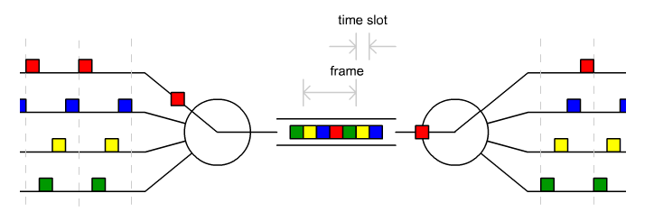

Consider that n = 5 (5 files with different sizes, should need more than five individual slots to send an entire file), slot size: 10 Byte. Each slot will have a specific format like below:

|  |  |  |  |  |
| --- | --- | --- | --- | --- |
| **Start Marker** | **Source Address** | **Destination Address** | **Data** | **End Marker** |

The frame format will be like below:

|  |  |  |  |  |  |  |
| --- | --- | --- | --- | --- | --- | --- |
| **Start Marker** | **Slot 01** | **Slot 02** | **Slot 03** | **Slot 04** | **Slot 05** | **End Marker** |

Now, implement the following:

1. Sync-TDM with backlogged traffic model

Output:

* Print the whole frame before sending to the other side.
* Print the whole frame after receiving.
* Store the outputs properly in the different files.